Spiraling Health Care in the U.S. vs Global

Problem to Hack: Spiraling Health Care in the U.S. vs Global, costing almost double of a decade ago, yet there have been no great strides in the quality of care per capita.

What is the Why? (Encompasses why the problem exists and the Pro/Con motivations & justifications) To Improve the Human Condition & Earth as an Organism

Hack/ Solution: Fit2Grid Nation, Community based Preventative Centers for Well-being.
At the current rate of increase, the cost of family insurance will reach twenty-seven thousand dollars or more in a decade, taking more than a fifth of every dollar that people earn.
Businesses will see their health-coverage expenses rise from ten per cent of total labor costs to seventeen per cent. Health-care spending will essentially devour all our future wage increases and economic growth. State budget costs for health care will more than double, and Medicare will run out of money in just eight years. The cost problem, people have come to realize, threatens not just our prosperity but our solvency.
https://epianalysis.wordpress.com/2012/07/18/usversuseurope/
And overall we have the highest rate of preventable death that would be amenable to healthcare intervention (deaths among people less than 75 years old that are from heart attacks, strokes, diabetes and bacterial infections); the U.S. has 96 such deaths per 100,000 people as compared to France’s 55 deaths.
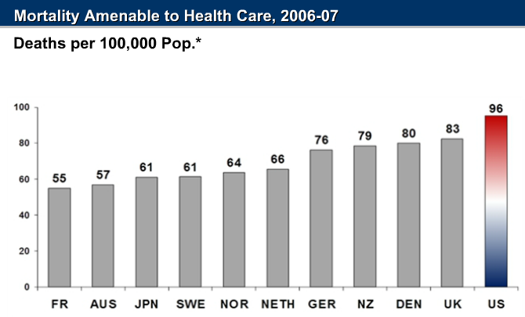

Death x Capita $  Multiple | Total Health Spending
 | Per capitac | Aver  Percent GDP | age annual real growth rate per capita: 1998–2008
Australia 205 | $3,353a | 8.5%a | 3.6%a
Canada 198 | $4,079e | 10.4%e | 3.4%e
Denmark 280 | $3,540a | 9.7%a | 3.5%a
France 198 | $3,696 | 11.2% | 2.3%
Germany 281 | $3,737 | 10.5% | 1.8%
Netherlands 264 | $4,063e | 9.9%e | 4.1%e
New Zealand 205 | $2,683 | 9.9% | 4.4%
Norway 320 | $5,003e | 8.5%e | 0.8%e
Sweden 207 | $3,470 | 9.4% | 3.9%
Switzerland 198 | $4,627e | 10.7%e | 1.9%e
United Kingdom 249 | $3,129 | 8.7% | 4.9%
United States 768 | $7,538 | 16.0% | 3.4%
OECD median 198 | $2,995 | 8.7% | 3.9%

Exhibit 1. Health Spending in Select OECD Countries, 2008

a 2007.

c Adjusted for differences in cost of living.
e Estimate.
Source: OECD Health Data 2010 (Oct. 2010).
Note: PPP = purchasing power parity—an estimate of the exchange rate required to equalize the purchasing power of different currencies, given the prices
of goods and services in the countries concerned. Source: OECD Health Data 2010 (Oct. 2010).
Exhibit 2. International Comparison of Spending on Health, 1980–2008

Average spending on health per capita ($US PPP)

Total expenditures on he as percent of GDP
Solution? Wellness & Prevention A healthy person becomes not a debt burden, but a Health & Wealth ReGenerator (increased productivity, less sick days) track health, metabolism, with a record of Exercise Accountability & improvement (this can be done via FiTGiGM tracking applications (proof of exercise, individual metabolism recording for tax credits reducing the amount of visits to the Hospital, drug usage, and Dangerous multiple Imaging (Radiology Scans).
Between 1999 and 2009, the average annual premium for employer-sponsored family insurance coverage rose from $5,800 to $13,400, and the average cost per Medicare beneficiary went from $5,500 to $11,900. The costs of our dysfunctional health-care system have already helped sink our auto industry, are draining state and federal coffers, and could ultimately imperil our ability to sustain universal coverage.
What have we gained by paying more than twice as much for medical care as we did a decade ago? We have already tried more drugs, more x-ray scans, more hospital visits and there have been no great strides in service. The mortality rate in relation to per capita spent on The health-care sector certainly employs more people and more machines than it did. But there have been no great strides in service. In Western Europe, most primary-care practices now use electronic health records and offer after-hours care; in the United States, most don’t. Improvement in demonstrated medical outcomes has been modest in most fields. The reason the system is a money drain is not that it’s so successful but that it’s fragmented, disorganized, and inconsistent; it’s neglectful of low-profit services like mental-health care, geriatrics, and primary care, and
almost giddy in its overuse of high-cost technologies such as radiology imaging, brand-name drugs, and many elective procedures. [ alternative to are:
- NIRS (Near Infrared Spectroscopy)
- Metabolism Tracking
- More Tough Hugs, not Drugs
  - Tough Hugs-
    - Health Advocacy
    - Mandated & Incentivized Exercise & Green Exercise Machine ownership (Fit2Grid sponsores Both)
      - employer $500 match
      - state $500 tax credit
      - Federal $500 credit
http://www.newyorker.com/magazine/2009/12/14/testing-testing-2?currentPage=all

The most obvious conclusion from this analysis is that a single-payer health system can contain costs and streamline clinical management protocols to avoid the unnecessary testing and procedures of private fee-for-service systems like the U.S. system, as well as incentivizing prevention. Nearly every other country in the analysis had a 100% government-based health insurance system, except for Germany at 89.5% (the U.S. has just 27.4% of the population covered through public-sector programs). As the single payer, the government needs to prevent disease to maintain a budget, rather than having the incentive of making money from managing a disease (doing procedures, ordering tests) but not preventing it, as in the fee-for-service private U.S. model. It can also bulk-purchase goods and supplies and help equalize salaries between current public sector rates and private sector networks that feed off of mutual referral systems and inflated pricing.

High U.S. obesity rate that translates into a high number of patients with chronic cardiovascular disease and diabetes that may increase spending as avoided deaths increase disease prevalence (that is, because people are chronically ill,

Examples/inspiration/Links:
http://innovation.cms.gov/

Actually, the U.S. seems to be an outlier from the overall curve between GDP and healthcare spending per capita. While most countries do spend more when they have more money, the U.S. disproportionately spends more, by about $3,000 per head.

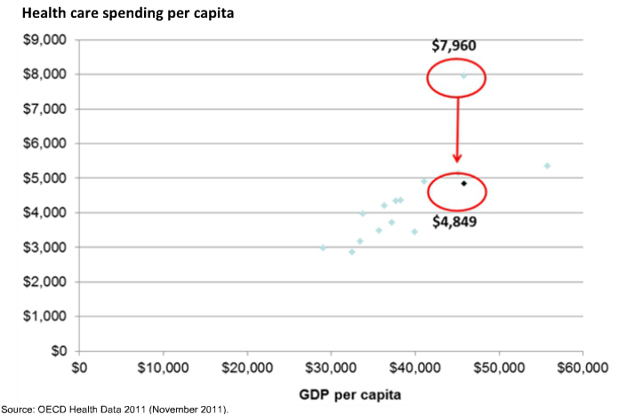

There are tests of various kinds of community wellness programs. The legislation also continues a stimulus-package program that funds comparative-effectiveness research—testing existing treatments for a condition against one another—because fewer treatment failures should mean lower costs.

http://www.newyorker.com/magazine/2009/12/14/testing-testing-2?currentPage=all

In the year 2006, each American’s healthcare cost $6,714, as compared to the $2,880 median among industrialized nations participating in the Organization for Economic Cooperation and Development (OECD), after adjusting for cost of living. As a percent of a country’s GDP, the U.S. also spent almost 16% of its GDP on healthcare as compared to between about 7% and 11% among other industrialized nations.

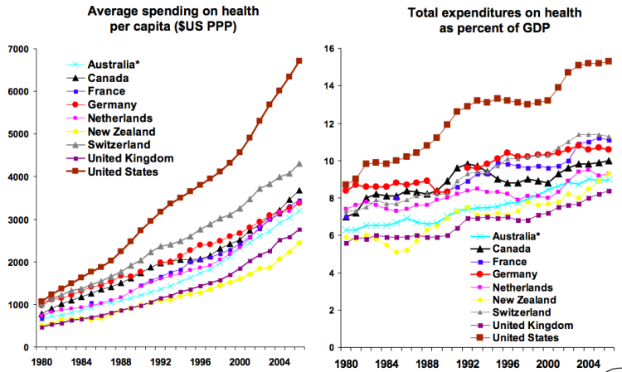

Describe how your organization is aligned with the strategy under which you are applying.* Our organization will create a unique health program in which Community Exercise Centers are developed indoors/outdoors for Parks, Schools, Health Centers, Residential Community Labs, and our Online (VR) Community .
What is unique about the Fit2Grid Program is that we will connect the exercise machines to a generator to provide electricity for the Lab, Gyms and Parks. Any excess electricity from Human Power, along with Solar, Wind, & Hydrogen based Energy Generation will be put into the grid to regenerate funds to support additional Fit2Grid Programs.
Our goal is to payit forward and back to the next & previous generation by creating the Fit2Grid experience to help Communities balance the playing field for the Health & Brain Power of the children, disabled & elderly.

How have you demonstrated success working with underserved communities in Los Angeles County?* We have many years of volunteer service with volunteering with organizations such as the Pomona Homeless Outreach Center, Western University of Health Sciences (to provide Free Diabetic Feet Exams), Chrysalis Center (clothing for Skid Row transients), Meals for Wheels (to bring food to the immobile elderly population), Clinica Luz Del Mundo (bi-lingual free clinic), and County Emergency Rooms to transcribe diagnostic charts for Physicians.
Efforts have begun for the following Activities:
-Funding of the space for the Fit2Grid Community Free gym in a disadvantaged city.
-Integrate, Train & Teach Metabolic tracking & Fitness Reporting: BMI, HR, B/P, & Lactate- threshold.
-Helping to Educate and increase Energy Conservation Awareness
-Complete a Guide Book & Program Studies to share with other Communities.
-Develop our FiTGiGM Center for Well being, a Progressive Approach for Social Cognitive Behavioral Health

CCF is interested in meeting the patient where they are at, encourages no wrong door to a health home, and supports quality care, as defined as care that is comprehensive, coordinated, continuous and evidence-based.
Describe your organization’s plan or existing activities for Existing Collaborative Partnerships and Focus (mental, dental, specialty spectrum, social services, coalitions) The Fit2Grid Neighborhood Exercise program will involve State-wide Aerobic Gamification that the Community plays together. The program will enable anyone to learn & teach Fitness Tracking. By helping to pull the Community together, members earn Fit2Grid E-coin Rewards which can be redeemed for valuable prizes, or accumulate in value. This pull would be in the form of an open-source effort to keep costs down for Free Community membership. We will partner with local Health Centers to encourage the (BMTT) Basic Metabolic Tracking Training for Patients with an "Rx to Exercise" from a Licensed Professional (Physician, Cognitive Behavior Therapist, Physical Therapist, LSW, Licensed Rehabilitation Professional).
We will initiated the pilot program in the community of Pomona, Ca, where the upward mobility of the children in the area is in the lowest 10% in the Nation. My goal is for programs such as the Fit2Grid Neighborhood Lab can create a more equitable life for these children so that there is hope for a better future. We plan to share the blueprints & developments so that that other communities may also start thier own Fit2Grid Program.

How is your organization preparing/prepared to deliver services as the Patient Protection and Affordable Care Act is implemented in Los Angeles County?
piraling Health Care cost almost double of a decade ago, yet there have been no great strides in the quality of care. The state of the our Nation's health, has deteriorated to having the highest global rate of preventable deaths per capita. These are death which are amenable to healthcare intervention (deaths among people less than 75 years old that are from heart attacks, strokes, diabetes and bacterial infections). As a example, the U.S. has 96 such deaths per 100,000 people as compared to France’s 55 deaths per 100,000 people. Health-care spending has become a burden for the State budget and Medicare reserves are depleting at a rapid pace.
There has been some progress in Lung Cancer incidents due to research and education leading to a massive shift in global perceptions and lifestyle exposure to carcinogenic toxins. Research and Education needs to impact the perception and lifestyle choices in all other areas of medicine. Traditional methods of treating illness when it's too late and the condition has already become chronic will only increase the costs of an aging population even further. The Solution? Increased Wellness & Prevention. A healthy person becomes not a debt burden, but a healthy wealth generator (less sick days, increased productivity).
We have already tried more drugs, more imaging scans, duplicated visits and the health-care sector certainly employs more people and more machines than before, however there have been no great strides in service. In Western Europe, most primary-care practices now use EHR and with a focus on Primary care, Prevention and Wellness. In the United States, despite high per capita costs, improvement in medical outcomes has been modest in most fields, while simultaneously neglecting low-profit services like mental-health care, geriatrics, and primary care.
Increasing a single-payer health system, as well as incentivizing prevention, can contain costs and streamline clinical management protocols to avoid the unnecessary testing and procedures of private fee-for-service systems which has a monetary incentive to increase transactions in our health care system,
The incentives can come in the form of employee match and revenue credits for citizens who choose Evidence Based healthy lifestyle choices, such as individual tracking of metabolism, with a record of Exercise Accountability & Reporting. (this can be accomplished via FiTGiGM tracking applications (Biometric proof of Exercise & Individual metabolism recording through low-cost wireless tracking devices). At the discretion of a Primary Care physician, an alternative choice of treatment can be offered to the patient which would include a Prescription for Exercise, monitored at Fit2Grid enabled Fitness Centers. The Fit2Grid tracking software & mobile apps can also be configured to monitor sleep and eating habits. The Fit2Grid Exercise alternative can alleviate costly duplicate visits, reduce drug usage & multiple Imaging.

Does your organization have a strategic plan?
Yes
No
*
Click to view help for this field.
We will review your LOI to determine alignment with CCF's health care funding priorities. As the next step in our standard process, you may be asked to email a strategic/business plan.

https://epianalysis.wordpress.com/2012/07/18/usversuseurope/

Sanjay Basu, MD, PhD, Assistant Professor of Medicine at Stanford University and Fellow of the London School of Hygiene and Tropical Medicine.
https://epianalysis.wordpress.com/about/

Dominant Theory of Organization for Economic Co-operation and Development (OECD) http://www.oecd.org/about/

David Squires at The Commonwealth Fund http://www.commonwealthfund.org/

Data to address five dominant theories:
(1) that the U.S. is wealthier so we just pay more in our economy;
- Actually, the U.S. seems to be an outlier from the overall curve between GDP and healthcare spending per capita. While most countries do spend more when they have more money, the U.S. disproportionately spends more, by about $3,000 per head.
(2) that we have an older and sicker population;
- Actually, the proportion of the population older than age 65 is 13% in America (see graph below), which is lower than the OECD median of 16% and much lower than Japan’s 23%
(3) that we utilize more healthcare (e.g., go to doctors, hospitals and emergency rooms more);
- The average number of physician visits per person in the U.S. is 4, below the OECD median of 6.4, and far below Japan’s 13 visits per person. Similarly, we have fewer hospital discharges at 131 per 1,000 people versus the OECD median of 160 and France’s 263 per 1,000. The average hospital stay per person is also lower in the U.S., at 5.4 days versus the OECD median of 5.9 days and Canada’s average of over one week.
(4) that the costs comes from our use of more technology; or
- Americans get less MRI scans per person than Japan, and have fewer hip and knee replacements and cardiac catheterizations than many European countries. The distribution of our spending among various sectors—basic medical care, diagnostics, hospitals, pharmaceuticals, and nursing homes—is not actually very different from European countries (we actually spend far less of our healthcare expenditures on nursing homes, at only 6.2% as compared to 20% in Switzerland, and slightly more than European countries on basic care)
(5) that we charge higher prices for the same goods and services.
- Among prescription drug costs, we pay far more than any other country, at least 20% more than Canada and over 60% more than New Zealand. For the same MRI’s and CT scans, we also pay more: $1,080 is the commercial average cost for an MRI in the U.S. as compared to $599 in Germany; at CT of the head costs $510 on average in the U.S. versus $272 in Germany. For a hip replacement, we again pay the most: $1,634 among public payers and $3,996 among private payers, versus $1,046 and $1,943 respectively in Australia. And physicians’ incomes are the highest: $187,000 on average among primary care doctors in the U.S. versus $93,000 in Australia; and $442,000 among orthopedic surgeons in the U.S. versus $154,000 in France.

What do they agree on ?

  - Sanjay Basu, MD, PhD, Assistant Professor of Medicine at Stanford University and Fellow of the London School of Hygiene and Tropical Medicine.
https://epianalysis.wordpress.com/about/

  - David Squires at The Commonwealth Fund http://www.commonwealthfund.org/

  - Dominant Theory of Organization for Economic Cooperation and Development (OECD) http://www.oecd.org/about/

Areas of agreement: So overall, our spending is out of proportion to our income, our population is younger than most of Europe, and we have fewer hospital stays with only typical technology use. This leaves us with the theory that higher:
- Highest Drug Prices
- imaging prices, along with
- higher physicians’ fees and income are driving our healthcare costs.
- Highest Prescription drug utilization in the World
- Highest supply, utilization, and price of diagnostic imaging (X-Rays)

- Health care spending all appear to be highest in the U.S.

Take Away Ratio: US vs. 12 other Industrialized Nations has the Highest preventable death per 1000, Highest per Capita healthcare cost, Highest Prescription Drug usage per capital, Highest Drug Prices, Highest Diagnostic Imaging Costs, Highest Lower extremity amputation, Highest Hospital Admission for Chronic Diseases,
Preventable Deaths/ per Capita Health care Cost

overall we have the highest rate of preventable death that would be amenable to healthcare intervention (deaths among people less than 75 years old that are from heart attacks, strokes, diabetes and bacterial infections);
, each American’s healthcare cost $6,714, as compared to the $2,880 median among industrialized nations participating in the Organization for Economic Cooperation and Development (OECD), after adjusting for cost of living. As a percent of a country’s GDP, the U.S. also spent almost 16% of its GDP on healthcare as compared to between about 7% and 11% among other industrialized nations.

WHAT IS DRIVING HIGHER HEALTH CARE SPENDING IN THE U.S.?
Spending on health care in the U.S. in 2008 far exceeded that seen in other countries. In both dollar figures and as a percentage of GDP, no country came within 70 percent of U.S. spending ($7,538 per capita, 16% GDP). This higher spending does not seem to simply reflect higher income. In Norway, the only country studied with higher per capita income than the U.S., health care spending accounted for only 8.5% of GDP.
Although much higher health care spending marks the U.S. as an outlier, containing spending growth is a shared challenge among these 12 countries. From 1998 to 2008, all countries experienced a rate of growth that exceeded inflation, with growth expected to continue. A recent analysis from the Centers for Medicare and Medicaid Services projects U.S. national health expenditure to grow at a rate of 6.1 percent from 2009 to 2019.9
These and other studies have found, contrary to often-cited explanations, the U.S. has a relatively young population, average or below-average rates of chronic conditions, and comparatively few doctor visits and hospitalizations compared with other industrialized countries.11 Instead, these studies suggest major reasons for higher spending include substantially higher prices and more fragmented care delivery that leads to duplication of resources and extensive use of poorly coordinated specialists.
Because of their uniformity, pharmaceuticals allow for a relatively direct comparison across countries. This analysis finds the U.S. to be highest among 12 countries on drug utilization, prices, and spending. In strong contrast, New Zealand stands out with the lowest per capita spending on pharmaceuticals—only 29 percent of what the U.S. spends
The 30 most-commonly prescribed drugs were three times cheaper in New Zealand than in the U.S.
New Zealand’s success suggests possible policy lessons for the U.S., including nationally negotiated rates, reference pricing, and comparative cost-effectiveness review for new medications. These policies are already widely employed among other countries.12
Despite much higher spending, U.S. performance in terms of quality is variable relative to other countries. While cancer care in the U.S. seems to be of particularly high quality based on five-year survival rates, the high rates of hospital admissions for chronic diseases suggest opportunities for improvement. These results echo previous comparative studies that find the U.S. to have middling or highly uneven quality. A 2010 cross-national study conducted by The Commonwealth Fund ranked the U.S. sixth of seven countries in terms of:
- quality, with average performance on effectiveness and
- patient-centeredness and
- low performance on safety and coordination.13
With chronic disease on the rise amidst an aging demographic and accounting for ever more health care spending, more effective treatment and management in primary care settings may have the potential to simultaneously improve patient care while preventing the unnecessary use of scarce and expensive resources.
Increase preventative medicine: Wellness (health fitness)., motivational Well-being. (Nutrition & Sleep)
Per capital ($3000 more than 12 other industrialized Nations), x

Do we get more in return?
The results of this hefty spending on the same drugs and (perhaps better) doctors doesn’t seem to clearly correlate into better outcomes. Mortality rates in U.S. hospitals after admission for a heart attack, for example, are just average—at 4.3% as compared to just 2.3% in Denmark. Similarly depressing results are available for respiratory diseases, cancers, and surgical or medical mistakes. And overall we have the highest rate of death that would be amenable to healthcare intervention (deaths among people less than 75 years old that are from heart attacks, strokes, diabetes and bacterial infections); the U.S. has 96 such deaths per 100,000 people as compared to France’s 55 deaths.
Marshall Plan for US Health Revitalization:
- From the Foundations & Countries whose Health & Welfare benefited from the US granted aid to ($13BB in 1950’s today’s equivalent @ 3% inflation is $54BB).
- The current State of US Health per capita is now the worse of the 12 Industrialized Nations. (Highest Mortality Rate & Highest per capita spent for Healthcare)
- We are requesting a Reverse Marshal Plan, to ameliorate the deterioration of per capita Health Care & Quality and for US Health Revitalization.
- Although the US may seem materialistically wealthy, are we any more Happier in terms of Physical & Mental Health in relation to the 12 other Industrialized Nations?
  - OECD per capita ratio indicate negative result in Health Quality per capita
  - World Happiness Index ranks the US last compared to 12 Industrial Nations
  - 64% National Dissatisfaction ratio
    - http://www.pewresearch.org/data-trend/national-conditions/national-satisfaction-2/
  - Although a majority of the world population is still considered "low income," the share for "poor" was halved between 2001 and 2011. The middle class also grew.
    - http://www.usnews.com/news/blogs/data-mine/2015/07/10/world-poverty-drops-with-china-leading-the-way

There's a new World Happiness Report out this week that ranks the most cheerful nations in the world.
Switzerland ranks No. 1, trailed by Iceland, Denmark, Norway, Canada, Finland, the Netherlands and Sweden. America ranks 15th, a slight improvement from last year, however, lowest of the 12 leading Industrial Nations.
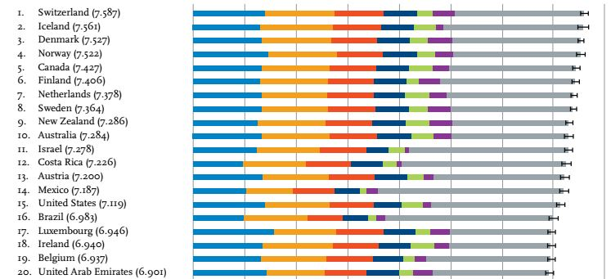

http://www.usnews.com/news/articles/2015/04/24/world-happiness-report-ranks-worlds-happiest-countries-of-2015

The Marshall plan, just as GARIOA, consisted of aid both in the form of grants and in the form of loans.^{[80]} Out of the total, 1.2 billion USD were loan-aid.^{[81}

The Marshall Plan (officially the European Recovery Program, ERP) was an American initiative to aid Europe, in which the United States gave $13 billion (approximately $120 billion in current dollar value) in economic support to help rebuild European economies after the end of World War II. The plan was in operation for four years beginning in April 1948. The goals of the United States were to rebuild war-devastated regions, remove trade barriers, modernize industry, make Europe prosperous again, and prevent the spread of communism.^{[1]} The Marshall Plan required a lessening of interstate barriers, a dropping of many petty regulations constraining business, and encouraged an increase in productivity, labour union membership, as well as the adoption of modern business procedures
https://epianalysis.wordpress.com/2012/07/18/usversuseurope/

Take away: Although the US has been a leader in Global Philanthropy and fixing everyone else’s problems in the World, we fail to acknowledge that:
- US health is in a state of denial:
  - continues to spending more on Health Care
  - takes more drugs
  - Living unhealthy Lifestyles which lead to physical & mental ailments which require even more drug usage and higher medical cost which perpetuates the downward Health Spiral.
- US health is suffering in per capita Physical & Mental illness equaling the highest of the 12 Industrialized Nations
  - http://www.theatlantic.com/health/archive/2011/10/why-more-americans-suffer-from-mental-disorders-than-anyone-else/246035/
    - Over a 12-month period, 27 percent of adults in the U.S. will experience some sort of mental health disorder, making the U.S. the country with the highest prevalence. Mental health disorders include mood disorders, anxiety disorders, attention deficit/hyperactivity disorder, and substance abuse. Over one’s entire lifetime, the average American has a 47.4 percent chance of having any kind of mental health disorder.
    - The incidence of mental health disorders varies widely across the globe, and determining the patterns is tricky. After the U.S., Ukraine, Colombia, New Zealand, Lebanon, and France have the next highest rates of mental health disorders of any kind, all falling between 18.9 percent and 21.4 percent in a 12-month period. Japan, the People’s Republic of China, Nigeria, and Israel have the lowest rates (between 6.0 percent and 7.4 percent), especially for depression.
- As Leaders with significant impact on Global Issues, we must maintain our Nation’s Physical & Mental Capacities to avoid issues of Critical Mass:

Ruth admitted to drug possession (Excessive Drug usage can alter normal plasticity of Neuronal function which can lead to abnormal behavior).

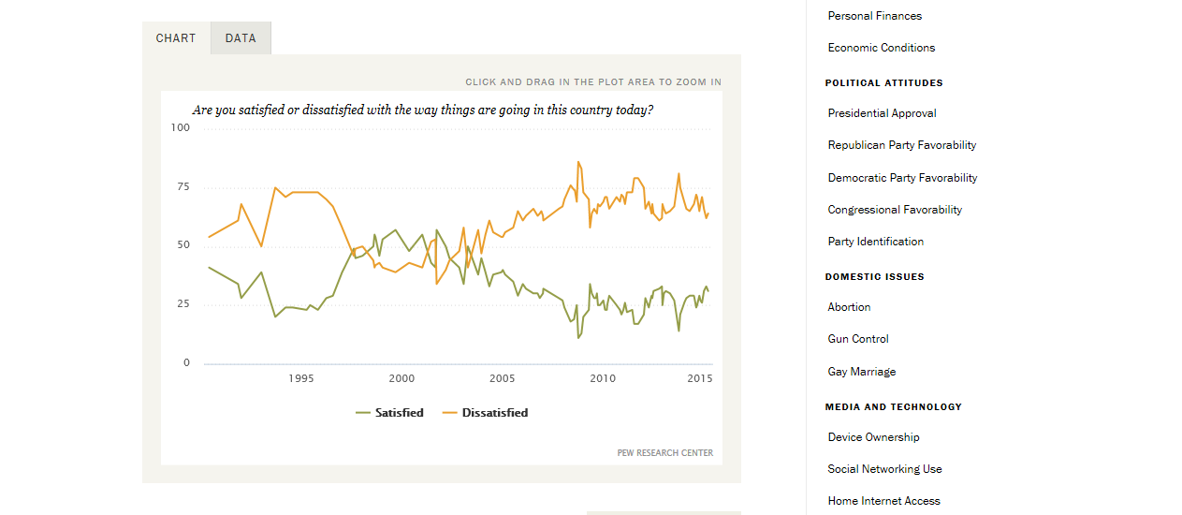

http://www.pewresearch.org/data-trend/national-conditions/national-satisfaction-2/

